Lab Evaluation:

Course Name: Object Oriented Programming |  |  |  | Course Code: CMPE221L
Assignment Type: Lab |  |  |  | Dated: 1-07-2026
Semester: 3rd |  |  |  | Session: 2025
Lab/Project/Assignment #: 3 |  |  |  | CLOs to be covered: CLO1
Lab Title: Getting Started with JAVA |  |  |  | Teacher Name: Hafiz Muhammad Mubashar
CLO1 | Implement abstraction and encapsulation to develop reusable classes for objects of real-world problems
Levels (Marks) | Level1 | Level2 | Level3 |  | Level4 | Level5 | Level6
(10)
Total |  |  |  |  |  |  | /10

Rubrics for Current Lab Evaluation
Scale | Marks | Level | Rubric
Excellent | 9-10 | L1 | Submitted all lab tasks, BONUS task, have good understanding.
Very Good | 7-8 | L2 | Submitted the lab tasks but have good understanding
Good | 5-6 | L3 | Submitted the lab tasks but have weak understanding.
Basic | 3-4 | L4 | Submitted the lab tasks but have no understanding.
Barely Acceptable | 1-2 | L5 | Submitted only one lab task.
Not Acceptable | 0 | L6 | Did not attempt

LAB No. 3

Lab Goals/Objectives:
- Getting Started with Java
- Acquiring practice with familiar programming constructs in JAVA

University Of Engineering and Technology, Lahore Computer Engineering Department
Equipment Required: Inteli J IDEA Edition Community, Net Beans with JDK 13 Version, Visual Studio.
Theory/Relevant Material: Write First Java Program
- Modify the Point class as discussed in class: that can represent 3-D point. Modify all the existing functions such that they work for 3-D point as well.
- Think of Time as an entity. Think of attributes and functions. Implement getter setters for its attributes. And write a function whatTime( int no_of_seconds_till_noon) and sets its attributes accordingly.
- You have graduated from University and now have a great job! You want to save for buying some physical asset(like house , car, Alienware or macbook etc). Now assets are never cheap, you realize you are going to have to save for several years before you can afford to make the down payment on it. We want to determine how long it will take you to save enough money to make the down payment given the following assumptions:
  - Call the cost of your dream asset total_cost.
  - Call the portion of the cost needed for a down payment portion_down_payment. For simplicity, assume that portion_down_payment = 0.25 (25%) of the total_cost.
  - Call the amount that you have saved thus far current_savings. You start with a current savings of $0.
  - Assume that you invest your current savings wisely, with an annual return of r (in other words, at the end of each month, you receive an additional current_savings*r/12 funds to put into your savings – the 12 is because r is an annual rate). Assume that your investments earn a return of r = 0.04 (4%).
  - Assume your monthly salary is monthly_salary.
  - Assume you are going to dedicate a certain amount of your salary each month to saving for the down payment. Call that portion_saved. This variable should be in decimal form (i.e. 0.1 for 10%).
  - At the end of each month, your savings will be increased by the return on your investment, plus a percentage of your monthly salary (annual salary / 12).
Write a program to calculate how many months it will take you to save up enough money for a down payment. You will want your main variables to be floats, so you should cast user inputs to floats.
Your program should ask the user to enter the following variables:
- The starting monthly salary (monthly_salary)
- The portion of salary to be saved (portion_saved)
- The cost of your dream home (total_cost)

Try different inputs and see how long it takes to save for a down payment.

Sample input

>>>

Enter your monthly salary: 10000
Enter the percent of your salary to save, as a decimal: .10 Enter the cost of your dream home: 1000000 Number of months: 183
>>>

Enter your monthly salary: 6666.66
Enter the percent of your salary to save, as a decimal: .15 Enter the cost of your dream home: 500000 Number of months: 105
>>>

TASK 1:
class point{
int x;
int y;
int z;

public point(int x,int y,int z) {
this.x = x;
this.y=y;
this.z=z;
}
public void display(){
System.out.println( x + " ," + " " + y + " , " + z);
}

public int getX() {
return x;
}

public void setX(int x) {
this.x = x;
}

public int getY() {
return y;
}

public void setY(int y) {
this.y = y;
}

public int getZ() {
return z;
}

public void setZ(int z) {
this.z = z;
}

double distance(point p){
int dx= p.x - this.x;
int dy= p.y - this.y;
int dz= p.z - this.z;
return Math.sqrt(dx*dx + dy*dy + dz*dz);

}
}

public class coordinates {
public static void main(String[] args){
point p1= new point(4,6, 7);
point p2 = new point(6,8, 8);
point p3 = new point(8,9,5);
int sum= p1.getX() + p1.getY() + p1.getZ();
System.out.println(sum);
p1.setX(10);
p1.setY(20);
p1.setZ(20);
p1.display();
p2.display();
p3.display();
System.out.println("the distance is" + " " + p1.distance(p2));
System.out.println("the distance is" + " " + p1.distance(p3));
System.out.println("the distance is" + " " + p2.distance(p3));

}
}

RESULT:
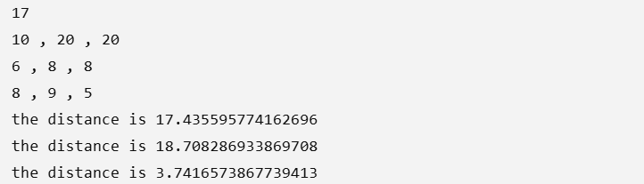

TASK 2:
import java.util.Scanner;
class seconds{
private int hour;
private int minutes;
private int seconds;

public int getHour() {
return hour;
}

public void setHour(int hour) {
this.hour = hour;
}

public int getMinutes() {
return minutes;
}

public void setMinutes(int minutes) {
this.minutes = minutes;
}

public int getSeconds() {
return seconds;
}

public void setSeconds(int seconds) {
this.seconds = seconds;
}
public void whatTime( int no_of_seconds_till_noon){
int h = no_of_seconds_till_noon / 3600;
int remaining_seconds = no_of_seconds_till_noon % 3600;
int min= remaining_seconds / 60;
int second= remaining_seconds % 60;
setHour(h);
setMinutes(min);
setSeconds(second);
}

public void display(){
System.out.println("hour" + " " + getHour() + " " + "minutes" + " " + getMinutes() + " seconds" + " " + getSeconds());

}
}
public class time {
public static void main(String[] args){
Scanner sc = new Scanner(System.in);
System.out.println("enter the seconds till noon");
int sec = sc.nextInt();
seconds t1= new seconds();
t1.whatTime(sec);
t1.display();

}

}

RESULT:
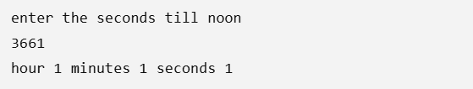

TASK 3:
import java.util.Scanner;
class calculate{
double monthly_salary;
double portion_saved;
double total_cost;
double portion_down_payment= 0.25;
double r = 0.04;
double current_savings = 0;
int months= 0;

}
public class calculator {
public static void main(String[] args){
calculate c1= new calculate();
Scanner sc= new Scanner(System.in);
System.out.print("Enter monthly salary: ");
c1.monthly_salary = sc.nextDouble();
System.out.print("Enter portion saved: ");
c1.portion_saved= sc.nextDouble();
System.out.print("Enter total cost: ");
c1.total_cost = sc.nextDouble();
double down_payment = c1.total_cost * c1.portion_down_payment;
while(c1.current_savings< down_payment){
c1.current_savings += c1.current_savings * c1.r / 12;
c1.current_savings += c1.monthly_salary * c1.portion_saved;
c1.months++;

}

System.out.println("months needed" + " " + c1.months);
}
}

RESULT:
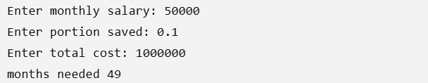

CONCLUSION:
These three programs demonstrate the practical use of Object-Oriented Programming (OOP) in Java by using classes, objects, constructors, methods, and encapsulation through getters and setters. The first program creates 3D point objects, modifies their coordinates, and calculates the distance between them. The second program converts a given number of seconds into hours, minutes, and seconds using arithmetic operations. The third program calculates how many months are needed to save enough money for a house down payment by using user input, calculations, interest, and a while loop. Overall, these programs show how Java can be used to solve real-world mathematical, time conversion, and financial problems while reinforcing core OOP concepts.

